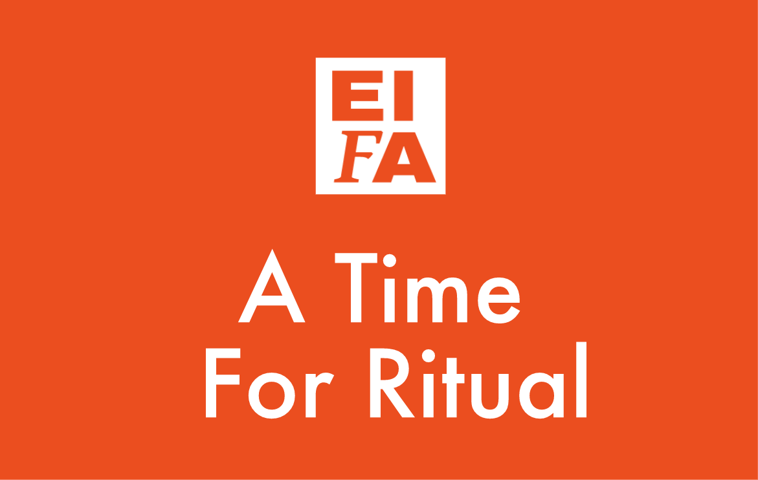

A TIME FOR RITUAL QUIZ: FOR TEACHERS

To be used in conjunction with our A Time For Ritual videos: check them out on our Youtube channel.

Produced by the Edinburgh Interfaith Association. For further information and supplementary educational materials visit:

www.edinburghinterfaith.com

Why not check out our other RME materials and videos on EIFA’s educational resource website: The Ground We Share

www.thegroundweshare.com

This resource introduces the faith groups of Edinburgh, what they believe, and offers students a chance to ask difficult questions (around contemporary moral issues, or tenets of belief) to local religious representatives, who answer them. Answers range topics such as same sex relationships, war & religion, euthanasia and embryo researching many more.

Christianity: Earth Day Ritual
Q1) Earth day celebrates through ritual  A: Gifts from parents, friends and loved ones  B: Gifts from the local shop  C: Gifts of creation  D: None of the above | Q2) The meditation recited at the beginning of this ritual includes awareness for  A: Light  B: Flowers  C: Stars  D: All of the above
Q3) The prayer in this ritual reminds us that:  A: The fertile earth is slowly being stripped of its riches.  B: The earth’s resources are unlimited.  C: We are no longer responsible for the earth.  D: None of the above. | Q4) The prayer also reminds us that our water is slowly being:  A: Being refilled with additional volume.  B: Being choked with chemicals  C: Being improved  D: Being cleaned.
Q5) The ritual concludes with a blessing of appreciation for:
A: The moon that is above us
B: The earth that is below us
C: The friends all around us
D: All of the above.

Ali Newell

Christianity: Prayer beads
Reverend Marion Chatterley
Q1) The ritual object described is:  - Bracelet  - Circle of faith  - Prayer beads  - None of the above | Q2) Each bead on the bracelet represents a:  - Sympbol of faith  - A person  - An animal  - An object
Q3) The faith leader holds each individual bead and:  - Prays for an individual person  - Prays for a group of people  - Prays for an object  - Prays for a place | Q4) This ritual enables the person to:  - Dream about a better world  - Celebrate kindness  - Generate energy  - Remember a group of people and a special time in her life
Q5) The bracelet also represents:
A. The entire world
B. Whole being
C. Friendship
D. Global peace

Christianity: Holy Communion
Rev David Paton Williams
Q1) What is a chalice?  A: A plate  B: A cup  C: A bowl  D: A spoon | Q2) In what ritual do Christians eat bread and drink wine?  A: The Eucharist  B: Holy Communion  C: Mass  D: All of the above
Q3) Communion “takes Christians back” to which event in the life of Jesus?  A: Turning water into wine  B: His baptism  C: The Last Supper  D: The resurrection | Q4) What does the Communion service remind Christians of?  A: That God will always be with them through the Holy Spirit  B: God’s love for them  C: What Jesus did for them in the crucifixion  D: All of the above
Q5) Why do Christians break bread?
A: To feed a crowd
B: To remind them of the Holy Spirit
C: To remind them of the Crucifixion
D: To remind them of the nativity

Islam: Prayer beads
Asif Sheikh
Q1) The rosary in the Muslim faith is called the:  A. Beads of hope  B. Mispa  C. String of faith  D. All of the above | Q2) The total number of beads are:  A. 50  B. 33  C. 66  D. 100
Q3) The number of sections on the beads are:  A. 3  B. 4  C. 5  D. 2 | Q4) The number of beads in each section is:  A. 20  B. 3B3  C. 41  D. None of the above
Q5) The prayer from the Qur’an that is recited whilst holding the beads says:
A. In Allah do hearts find satisfaction and rest,
B. Thank you for life.
C. Thank you for food and water.
D. Remember others.

Islam: the Qur’an
Imam Yahya Barry
Q1) The Qur’an is:  A: The word of God, revealed to Mohammed (PBUH)  B: The word of the Prophet  C: The word of the Prophet given to God  D: All of the above | Q2) How many years of revelation did it take for the Qur’an to be gathered together?  A: 10 years  B: 13 years  C: 23 years  D: 33 years
Q3) What is the name of a chapter of the Qur’an?  A: A verse  B: A Surah  C: An Ayah  D: An Ayat | Q4) What language was the Qur’an revealed in?  A: English  B: French  C: Arabic  D: Farsi
Q5) The Qur’an is a book…
A: Full of guidance for Muslims
B: Which teaches Muslims how to live a good life
C: Which helps Muslims live a righteous life on this earth
D: All of the above

Judaism: Shabbat candles, Kiddush cup and challah
Professor Joe Goldblatt

Q1) The Jewish Sabbath begins at sundown on:  A. Wednesday  B. Saturday  C. Friday  D. Sunday | Q2) During the Jewish Sabbath ritual candles are lit, wine is drunk and:  A. Bread is tasted.  B. Dates are passed.  C. Raisins are eaten.  D. Almonds are passed.
Q3) The bread served during the Shabbat ritual is called the:  A. Pumpernickel  B. Rye  C. Challah  D. Brown | Q4) The Jewish Sabbath ends on:  A. Saturday at sundown  B. Thursday at sundown  C. Monday at sundown  D. Friday at sundown
Q5) When blessing the candles during the Shabbat ritual it is customary to:
A. Close your hands
B. Raise your hands
C. Clap your hands
D. Close your eyes to concentrate on God

Judaism: Havdalah spices, Kiddush cup and candle
Rabbi David Rose
Q1) The Jewish Havdalah ritual is conducted on:  A. Friday morning  B. Tuesday afternoon  C. Saturday at sundown  D. Sunday at sundown | Q2) During the Havdalah ritual spices are smelled to remember:  1. To work hard in the week to come  2. The sweetness of the Sabbath  3. Loved ones who have passed away  4. None of the above
Q3) During the Havdalah ritual a candle is lit and then extinguished using:  A. Wine  B. Water  C. Salt  D. Sand | Q4) During the Havdalah ritual a blessing is made over the cup containing the:  A. Water  B. Juice  C. Wine  D. Salt water
Q5) At the end of the Havdalah ritual Jews say to one another:
A. Peace be with you
B. Shavuo Tov (Have a good week)
C. Travel safely
D. Go well

Sikhism: Music and Ritual
Dharmveer Singh
Q1) The Sikh ritual object being played is called a:  - Vanger  - Accordion  - Harmonium  - A and C | Q2) The Sikh place of worship is called the:  - Chapel  - Gurdwara  - Club  - Room
Q3) The Sikh scriptures are called the  - Bible  - Psalms  - Sonnets  - Guru Granth Sahib | Q4) The word for God in the Sikh faith is:  - Libu  - Allah  - Lord  - Father
Q5) Libu also means:
  - Wondrous creator
  - Almighty
  - Magnificent
  - A and B

Hinduism: Friday rituals
Shipra Kohli
Q1) In Hindu philosophy Friday is the day of:  A. The God  B. The Goddess  C. The Almighty  D. The magnificent one | Q2) The Hindu ritual begins with:  A. Ringing the gong  B. Sounding the bell  C. Lighting the lamp  D. None of the above
Q3) At some Hindu houses the lamp is lit:  A. Once per week  B. Once per day  C. Five times per day  D. At dawn and dusk | Q4) When lighting the lamp a prayer is said that includes:  A. The light is bright  B. The lamp leads us from darkness to light  C. The light is eternal  D. The lamp is briefly lit
Q5) At the end of the ritual:
A. Small bells are rung
B. A tambourine is sounded
C: A horn is blown
D. A drum is beaten

Baha’i Faith: Marriage Rituals
Ruhy Parris
Q1) The Baha’i faith does not generally use:  A. Prayers  B. Meditations  C. Ritual objects  D. Symbols | Q2) The ritual being performed by the Baha’i faith leader is used for:  A. Deaths  B. Marriages  C. Births  D. All of the above
Q3) The Baha’i faith is a new world religious that originated in the middle of the:  A. 15th century  B. 16th century  C. 19th century  D. 20th century. | Q4) The believers in the Baha’i faith are followers of:  A. Baháʼu'lláh  B. Moses  C. Allah  D. Abraham
Q5) The Baha’i faith is devoid of most rituals, however, one that is celebrated is entitled the:
A. Awakening
B. Great celebration
C. The High Marriage
D. The emancipation

Buddhism: Bowl
Allen Kerr
Q1) The Buddhist monks used the bowl for:  A. Carrying holy water  B. Collecting food in their begging bowl.  C. Collecting coins.  D. None of the above | Q2) Buddhists now use the bowl to:  - Distribute food  - Collect water  - Cleanse themselves  - Make a sound to commence meditation
Q3) The Buddhist begins the meditation by:  A. Inviting the sound  B. Rubbing the bowl  C. Striking the bowl  D. All of the above | 4. In buddhism there are _____ schools of thought and practice  A. Many  B. Few  C. Two  D. No
Q5) The sound of the bell shows:
- Heaven opening
- Resonation with nature
- You are pausing normal life
- You’re hungry

